LabSheet 7
Spring program to create a simple application of spring Boot using eclipse IDE.
Problem Statement : display using Spring Boot.

Creating a Spring Boot Project
Following are the steps to create a simple Spring Boot Project.
Step 1: Open the Spring initializr https://start.spring.io.
Step 2: Provide the Group and Artifact name. We have provided Group name com.pu and Artifact spring-boot-example.
Step 3: Now click on the Generate button.
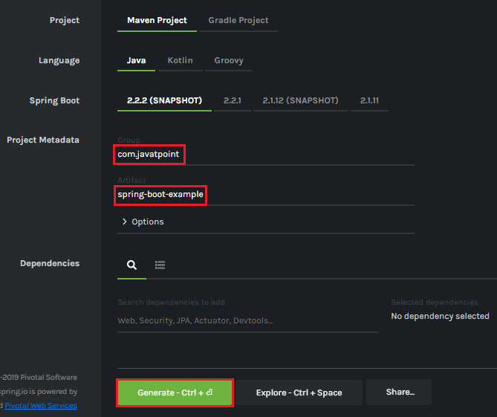
When we click on the Generate button, it starts packing the project in a .rar file and downloads the project.
Step 4: Extract the RAR file.
Step 5: Import the folder.
File -> Import -> Existing Maven Project -> Next -> Browse -> Select the project -> Finish
It takes some time to import the project. When the project imports successfully, we can see the project directory in the Package Explorer. The following image shows the project directory:
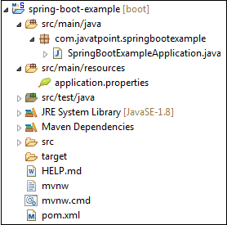
SpringBootExampleApplication.java
- package com.pu.springbootexample;
- import org.springframework.boot.SpringApplication;
- import org.springframework.boot.autoconfigure.SpringBootApplication;
- @SpringBootApplication
- public class SpringBootExampleApplication
- {
- public static void main(String[] args)
- {
- SpringApplication.run(SpringBootExampleApplication.class, args);
- }
- }
pom.xml
- <?xml version="1.0" encoding="UTF-8"?>
- <project xmlns="http://maven.apache.org/POM/4.0.0" xmlns:xsi=http://www.w3.org/2001/XMLSchema-instance xsi:schemaLocation="http://maven.apache.org/POM/4.0.0 https://maven.apache.org/xsd/maven-4.0.0.xsd">
- <modelVersion>4.0.0</modelVersion>
- <parent>
- <groupId>org.springframework.boot</groupId>
- <artifactId>spring-boot-starter-parent</artifactId>
- <version>2.2.2.BUILD-SNAPSHOT</version>
- <relativePath/> <!-- lookup parent from repository -->
- </parent>
- <groupId>com.javatpoint</groupId>
- <artifactId>spring-boot-example</artifactId>
- <version>0.0.1-SNAPSHOT</version>
- <name>spring-boot-example</name>
- <description>Demo project for Spring Boot</description>
- <properties>
- <java.version>17</java.version>
- </properties>
- <dependencies>
- <dependency>
- <groupId>org.springframework.boot</groupId>
- <artifactId>spring-boot-starter</artifactId>
- </dependency>
- <dependency>
- <groupId>org.springframework.boot</groupId>
- <artifactId>spring-boot-starter-test</artifactId>
- <scope>test</scope>
- <exclusions>
- <exclusion>
- <groupId>org.junit.vintage</groupId>
- <artifactId>junit-vintage-engine</artifactId>
- </exclusion>
- </exclusions>
- </dependency>
- </dependencies>
- <build>
- <plugins>
- <plugin>
- <groupId>org.springframework.boot</groupId>
- <artifactId>spring-boot-maven-plugin</artifactId>
- </plugin>
- </plugins>
- </build>
- <repositories>
- <repository>
- <id>spring-milestones</id>
- <name>Spring Milestones</name>
- <url>https://repo.spring.io/milestone</url>
- </repository>
- <repository>
- <id>spring-snapshots</id>
- <name>Spring Snapshots</name>
- <url>https://repo.spring.io/snapshot</url>
- <snapshots>
- <enabled>true</enabled>
- </snapshots>
- </repository>
- </repositories>
- <pluginRepositories>
- <pluginRepository>
- <id>spring-milestones</id>
- <name>Spring Milestones</name>
- <url>https://repo.spring.io/milestone</url>
- </pluginRepository>
- <pluginRepository>
- <id>spring-snapshots</id>
- <name>Spring Snapshots</name>
- <url>https://repo.spring.io/snapshot</url>
- <snapshots>
- <enabled>true</enabled>
- </snapshots>
- </pluginRepository>
- </pluginRepositories>
- </project>
Step 6: Run the SpringBootExampleApplication.java file.
Right-click on the file -> Run As -> Java Applications
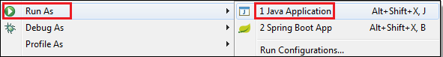
The following image shows the application runs successfully.

